**Graph Representations worksheet**

Graphs are simply abstractions of real-world problems, and can be represented in various ways. Draw the graphs / representations below to check your understanding.

1. Given the adjacency matrix of an un-weighted, un-directed graph shown below, drawing the resulting graph:

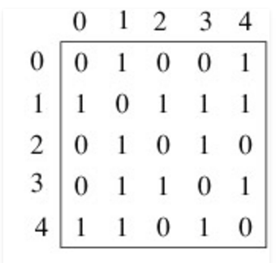

Solution: [click here](https://www.dropbox.com/s/q4l7u5l2vwqaxmb/Graph%20from%20adjacency%20matrix.png?dl=0)

1. Convert the adjacency matrix above to an adjacency list (an array of linked lists).

Solution: [click here](https://www.dropbox.com/s/7h4qxu7w8sdeh26/Adjacency%20list%20representation.png?dl=0)

1. Draw an adjacency list for the un-directed, weighted graph shown below:

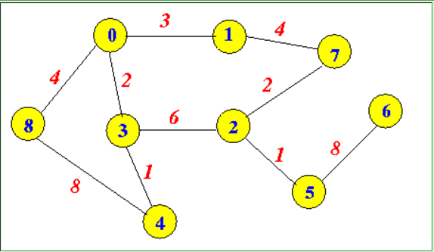

Solution: [click here](https://www.dropbox.com/s/io78evv2avozoo4/Adjacency%20list%20weighted%20undirected%20graph.png?dl=0)

1. Write the edge list for the un-directed graph depicted below:

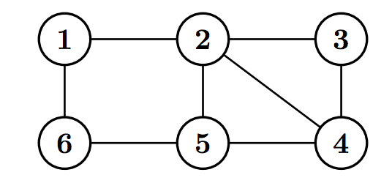

Solution: [click here](https://www.dropbox.com/s/n0u1ejznrnuqw3m/Edge%20list%20graph%20representation.png?dl=0)

1. Draw the (directed, weighted) graph represented by the adjacency matrix below, where -1 represents no connection, 0 represents a connection to itself, and a positive integer represents the weight of the connection.

A B C

A 0 1 5

B -1 0 1

C -1 -1 0

Solution: [click here](https://www.dropbox.com/s/7nd3yxysug1t9wu/Directed%2C%20weighted%20graph.png?dl=0)